Early voting social posts
Sample County Supervisor of Elections | Draft for review
One early voting announcement, written for Facebook, Instagram, X, Nextdoor, and LinkedIn. Every version uses the same facts from the early voting rows of the verification table, word for word except where X needed shorter forms to fit. Every version follows the brand board: a plain, calm voice, #SampleCountyVotes, and the sign-off on the longer posts.
Character counts include spaces and line breaks. Copy a post by clicking in its box, selecting the text, and pasting it into the platform.

Before you post
- Check the link. The posts link to https://samplecounty.example/voters/early-voting.html, a made-up address because Sample County is fictional. Replace it with your office's real early voting page, then open it once to make sure it works.
- Look over the image. There was no image in the folder, so I made a draft graphic from the same facts, in the brand colors and fonts. It's in the “Image and alt text” section. The alt text describes this graphic. If you post a different image, the alt text needs to be rewritten to match it.
- Add the logo if you want it. The logo file wasn't in the folder either, so the graphic spells out the office name in the white band at the top. The brand board says to use the logo as-is, on white, in a corner.
- Instagram: links in captions aren't clickable, so the caption lists all three addresses and points to the link in your bio. Make sure your bio link goes to the early voting page.
- Nextdoor: paste the subject line into the subject box. Keep https:// on the link. Nextdoor's agency guide says links without it won't be clickable.

The posts

X
Short version: dates, hours, the three site names, the ID reminder, and the link. The addresses are on the linked page and on the graphic. No sign-off, since the brand board saves it for longer posts.
Early voting: Feb. 28 to March 7, 9 a.m. to 5 p.m. each day.

Any registered voter can vote at any site:
Sample County Main Library
Example Civic Center
Placeholder Park Recreation Center

Bring a photo ID with your signature.
https://samplecounty.example/voters/early-voting.html #SampleCountyVotes
Character count: 269 of 280 (X counts the link as 23 characters, as you asked; 11 to spare)

Facebook
Full version with all three addresses and a clickable link.
Early voting runs Saturday, February 28 through Saturday, March 7, 2099. Voting hours are 9 a.m. to 5 p.m. each day.

Any registered voter in Sample County can vote at any early voting site. Pick the site that works best for you:

Sample County Main Library, 200 Library Lane, Sampleton
Example Civic Center, 45 Civic Way, Example Springs
Placeholder Park Recreation Center, 9 Park Road, Placeholder Beach

Bring a photo ID with your signature.

Check the details here: https://samplecounty.example/voters/early-voting.html

— Sample County Supervisor of Elections Pat Placeholder

#SampleCountyVotes
Character count: 600

Instagram
Instagram doesn't make links in captions clickable, so this version lists every address and points to the link in your bio.
Early voting runs Saturday, February 28 through Saturday, March 7, 2099. Voting hours are 9 a.m. to 5 p.m. each day.

Any registered voter in Sample County can vote at any early voting site:

Sample County Main Library, 200 Library Lane, Sampleton
Example Civic Center, 45 Civic Way, Example Springs
Placeholder Park Recreation Center, 9 Park Road, Placeholder Beach

Bring a photo ID with your signature.

Check the details at the link in our bio, or go to samplecounty.example/voters/early-voting.html

— Sample County Supervisor of Elections Pat Placeholder

#SampleCountyVotes
Character count: 580 of 2,200

Nextdoor
Written to neighbors in a conversational voice, as Nextdoor's agency guide suggests.
Subject line
Early voting: Feb. 28 to March 7 at 3 sites
Character count: 43 of 50 (Nextdoor's agency guide asks for 50 characters or less)
Message
Hi neighbors,

Early voting runs Saturday, February 28 through Saturday, March 7, 2099. Voting hours are 9 a.m. to 5 p.m. each day.

Any registered voter in Sample County can vote at any early voting site. Pick whichever one is closest to you:

Sample County Main Library, 200 Library Lane, Sampleton
Example Civic Center, 45 Civic Way, Example Springs
Placeholder Park Recreation Center, 9 Park Road, Placeholder Beach

Bring a photo ID with your signature.

Check the details here: https://samplecounty.example/voters/early-voting.html

— Sample County Supervisor of Elections Pat Placeholder

#SampleCountyVotes
Character count: 614 (Nextdoor's agency guide sets no length limit for messages)

LinkedIn
Same facts, with a line asking employers and community groups to pass it along.
Early voting runs Saturday, February 28 through Saturday, March 7, 2099. Voting hours are 9 a.m. to 5 p.m. each day.

Any registered voter in Sample County can vote at any early voting site:

Sample County Main Library, 200 Library Lane, Sampleton
Example Civic Center, 45 Civic Way, Example Springs
Placeholder Park Recreation Center, 9 Park Road, Placeholder Beach

Bring a photo ID with your signature.

Employers and community groups: please share this with your teams and members.

Check the details here: https://samplecounty.example/voters/early-voting.html

— Sample County Supervisor of Elections Pat Placeholder

#SampleCountyVotes
Character count: 641 of 3,000

Image and alt text
Draft graphic, 1080 by 1350 pixels (a tall 4:5 shape). It uses only the facts in the posts. To save it as a picture file, right-click it in Word and choose Save as Picture. Nextdoor's agency guide says wide images display best there. This one is tall, so check how it looks in the Nextdoor preview before you post.
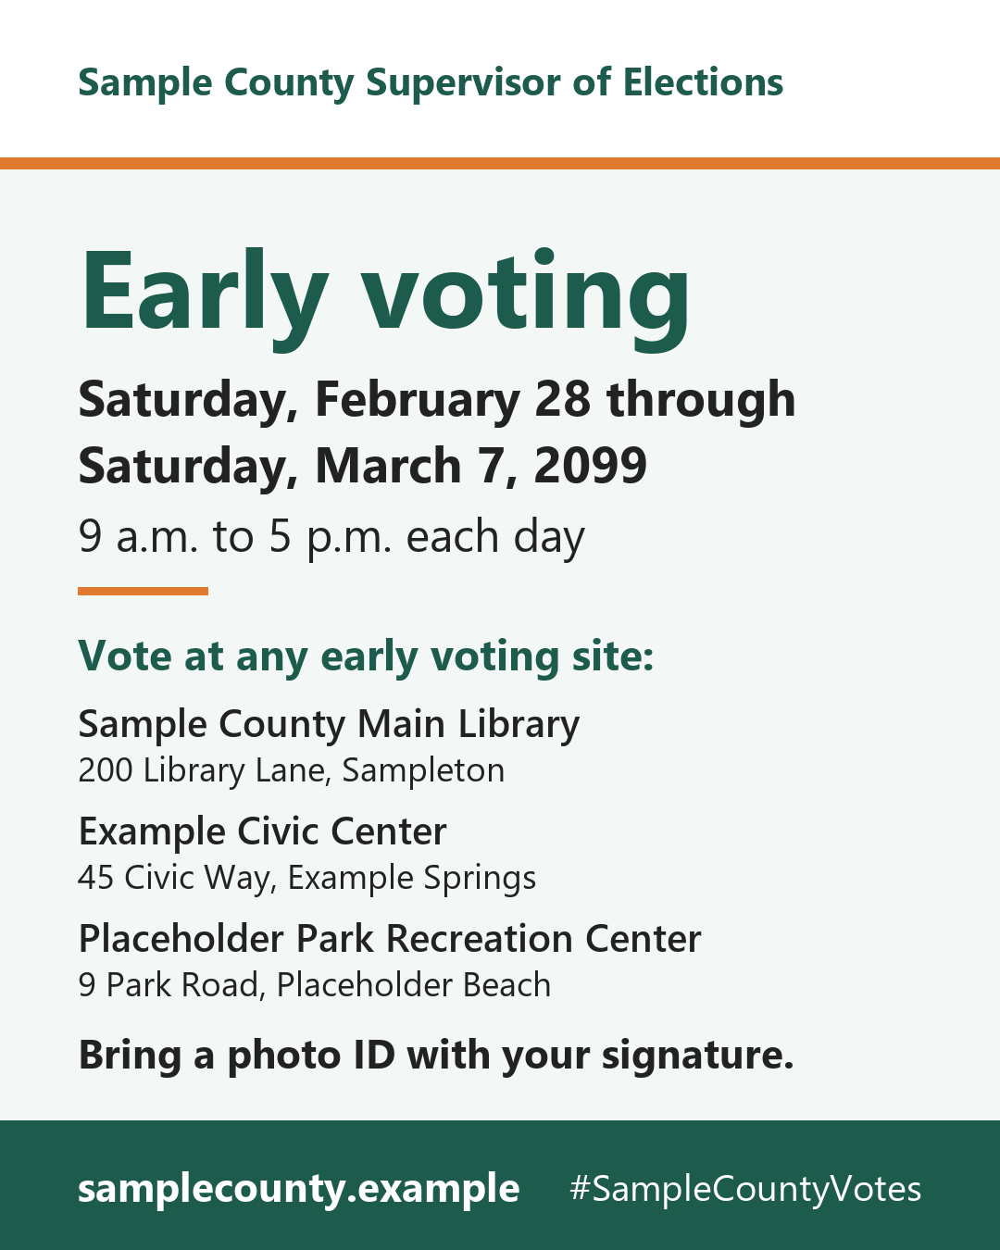
Alt text (use the same text on every platform)
Graphic from the Sample County Supervisor of Elections. Early voting: Saturday, February 28 through Saturday, March 7, 2099, 9 a.m. to 5 p.m. each day. Vote at any early voting site: Sample County Main Library, 200 Library Lane, Sampleton; Example Civic Center, 45 Civic Way, Example Springs; Placeholder Park Recreation Center, 9 Park Road, Placeholder Beach. Bring a photo ID with your signature. samplecounty.example
Character count: 419 (X and Instagram allow up to 1,000)
Short alt text (only if a platform won't take the full one)
Early voting graphic: Feb. 28 to March 7, 2099, 9 a.m. to 5 p.m. each day, at 3 sites. Bring a photo ID with your signature.
Character count: 124
Where to paste the alt text
- X: after you add the image, select +ALT on it, paste, and select Done.
- Instagram: after you pick the image, tap Advanced settings, then Write alt text.
- Facebook: Facebook writes its own automatic alt text if you don't. Edit the photo's alt text and replace it with this.
- LinkedIn: after you add the image, select Alt text (ALT on mobile) below it.
- Nextdoor: I couldn't find an alt text setting in Nextdoor's help pages. The post text says everything the image says, so screen reader users still get the full message.

Facts used
From the seven early voting rows of the verification table (rows 2 to 8), verified by PP on January 28, 2099. Nothing from the vote-by-mail or Election Day rows is in these posts.
Row | Fact | As the table writes it
2 | Dates | Saturday, February 28 through Saturday, March 7, 2099
3 | Hours | 9 a.m. to 5 p.m. each day
4 | Site | Sample County Main Library, 200 Library Lane, Sampleton
5 | Site | Example Civic Center, 45 Civic Way, Example Springs
6 | Site | Placeholder Park Recreation Center, 9 Park Road, Placeholder Beach
7 | Who can vote where | Any registered voter in Sample County can vote at any early voting site.
8 | What to bring | Bring a photo ID with your signature.

All seven rows cite https://samplecounty.example/voters/early-voting.html as the source, the same page the posts link to.

Same message on every platform
This table was filled in by checking each post's text against the facts above, so it shows what's really in each post.
What it says | X | Facebook | Instagram | Nextdoor | LinkedIn
Dates | Yes (short form) | Yes | Yes | Yes | Yes
Hours | Yes | Yes | Yes | Yes | Yes
All 3 site names | Yes | Yes | Yes | Yes | Yes
Site addresses | On the link and graphic | Yes | Yes | Yes | Yes
Any registered voter, any site | Yes (short form) | Yes | Yes | Yes | Yes
Photo ID with your signature | Yes | Yes | Yes | Yes | Yes
Where to check | Clickable link | Clickable link | Bio link and typed address | Clickable link | Clickable link
#SampleCountyVotes | Yes | Yes | Yes | Yes | Yes
Sign-off | No (short post) | Yes | Yes | Yes | Yes

Words to avoid from the brand board (absentee ballot, polling station, the elections office) don't appear in any post.

Sources
Your files:
- Verification table - March 10, 2099 special election.xlsx (early voting rows 2 to 8)
- Brand board - approved.docx (voice, hashtag, sign-off, words we use, colors, fonts, logo rule)
Platform help pages (checked October 1, 2026):
- X: Counting characters (280 limit; every link counts as 23): https://docs.x.com/resources/fundamentals/counting-characters
- X Help Center: Image descriptions (up to 1,000 characters): https://help.x.com/en/using-x/picture-descriptions
- Meta for Developers: Instagram media (captions up to 2,200 characters; alt text up to 1,000): https://developers.facebook.com/docs/instagram-platform/instagram-graph-api/reference/ig-user/media
- Instagram Help Center: Alt text on a photo: https://help.instagram.com/503708446705527
- Instagram Help Center: Add a website to your profile: https://help.instagram.com/362497417173378
- Facebook Help Center: Automatic alt text: https://www.facebook.com/help/216219865403298
- LinkedIn Help: Post and share updates (3,000-character limit): https://www.linkedin.com/help/linkedin/answer/a528176
- LinkedIn Help: Add alternative text to images: https://www.linkedin.com/help/linkedin/answer/a519856
- Nextdoor for Public Agencies training manual (subject lines, message length, links, tone): https://business.nextdoor.com/en-us/public-agency/resources/best-practices/nextdoor-for-public-agencies-training-manual

